

LQ-Washing Label Printer

Add: Room 2201, Henghui Building, No. 568, Hengfeng Road, Jing 'an District, Shanghai
TEL：86-21-63177436 FAX：86-21-63538343
Email: sales@upg-digital.com

LQ-Washing Label Printer
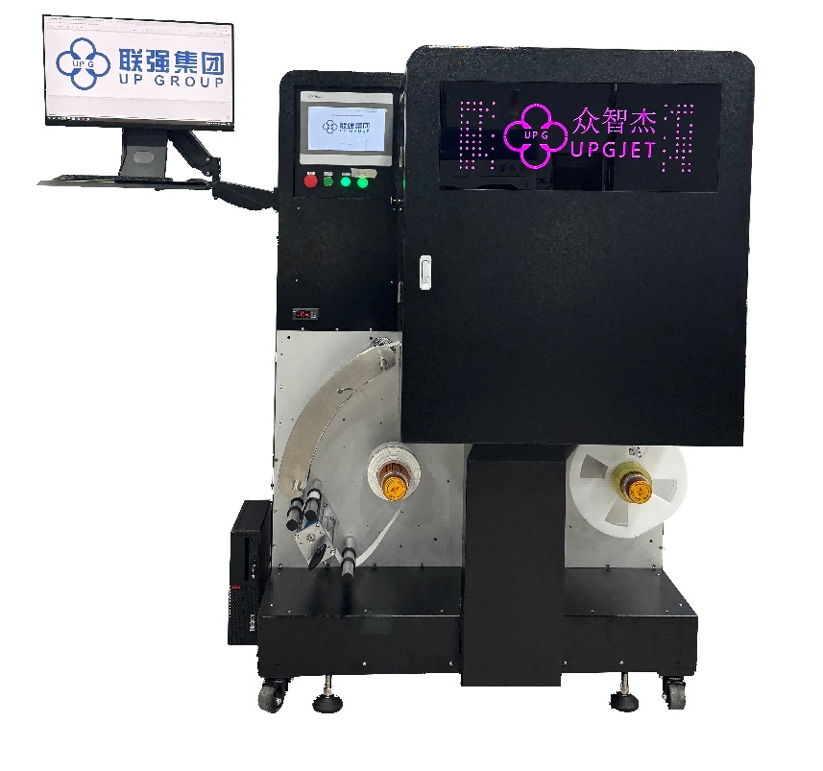
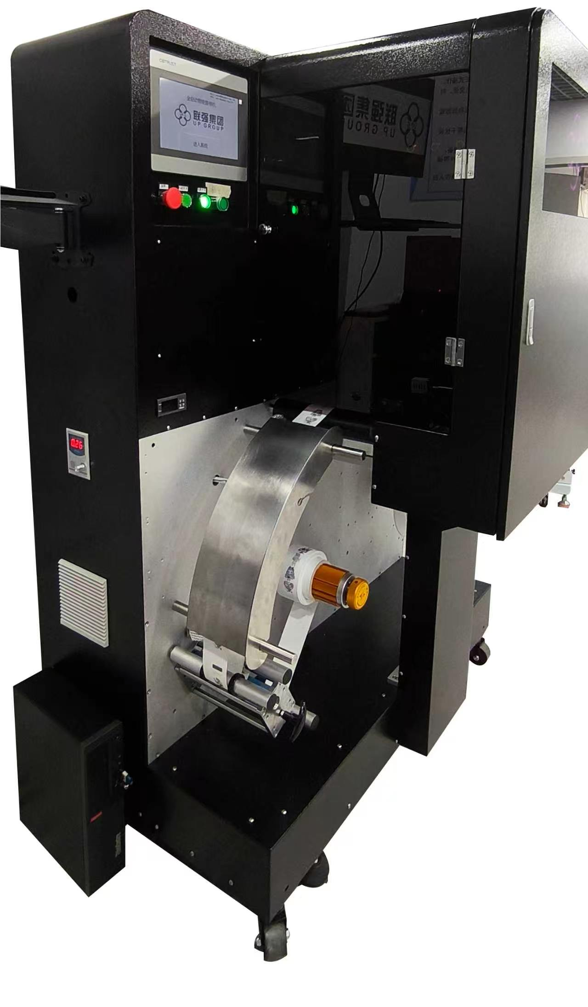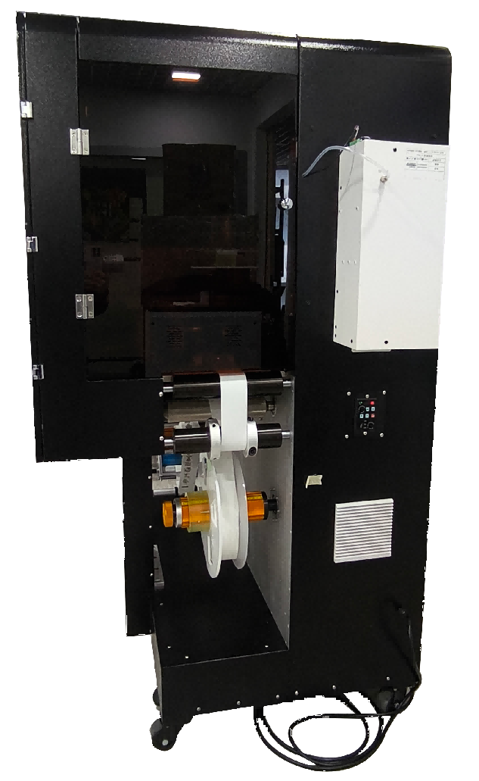
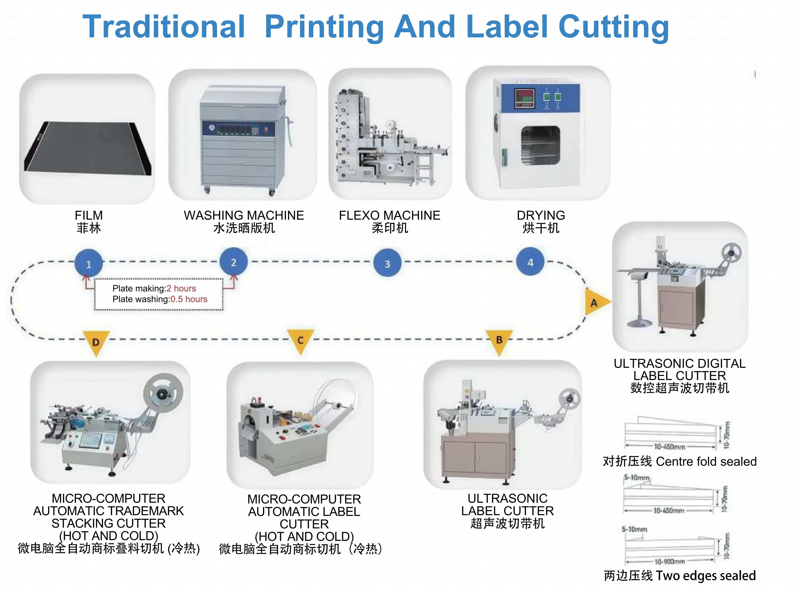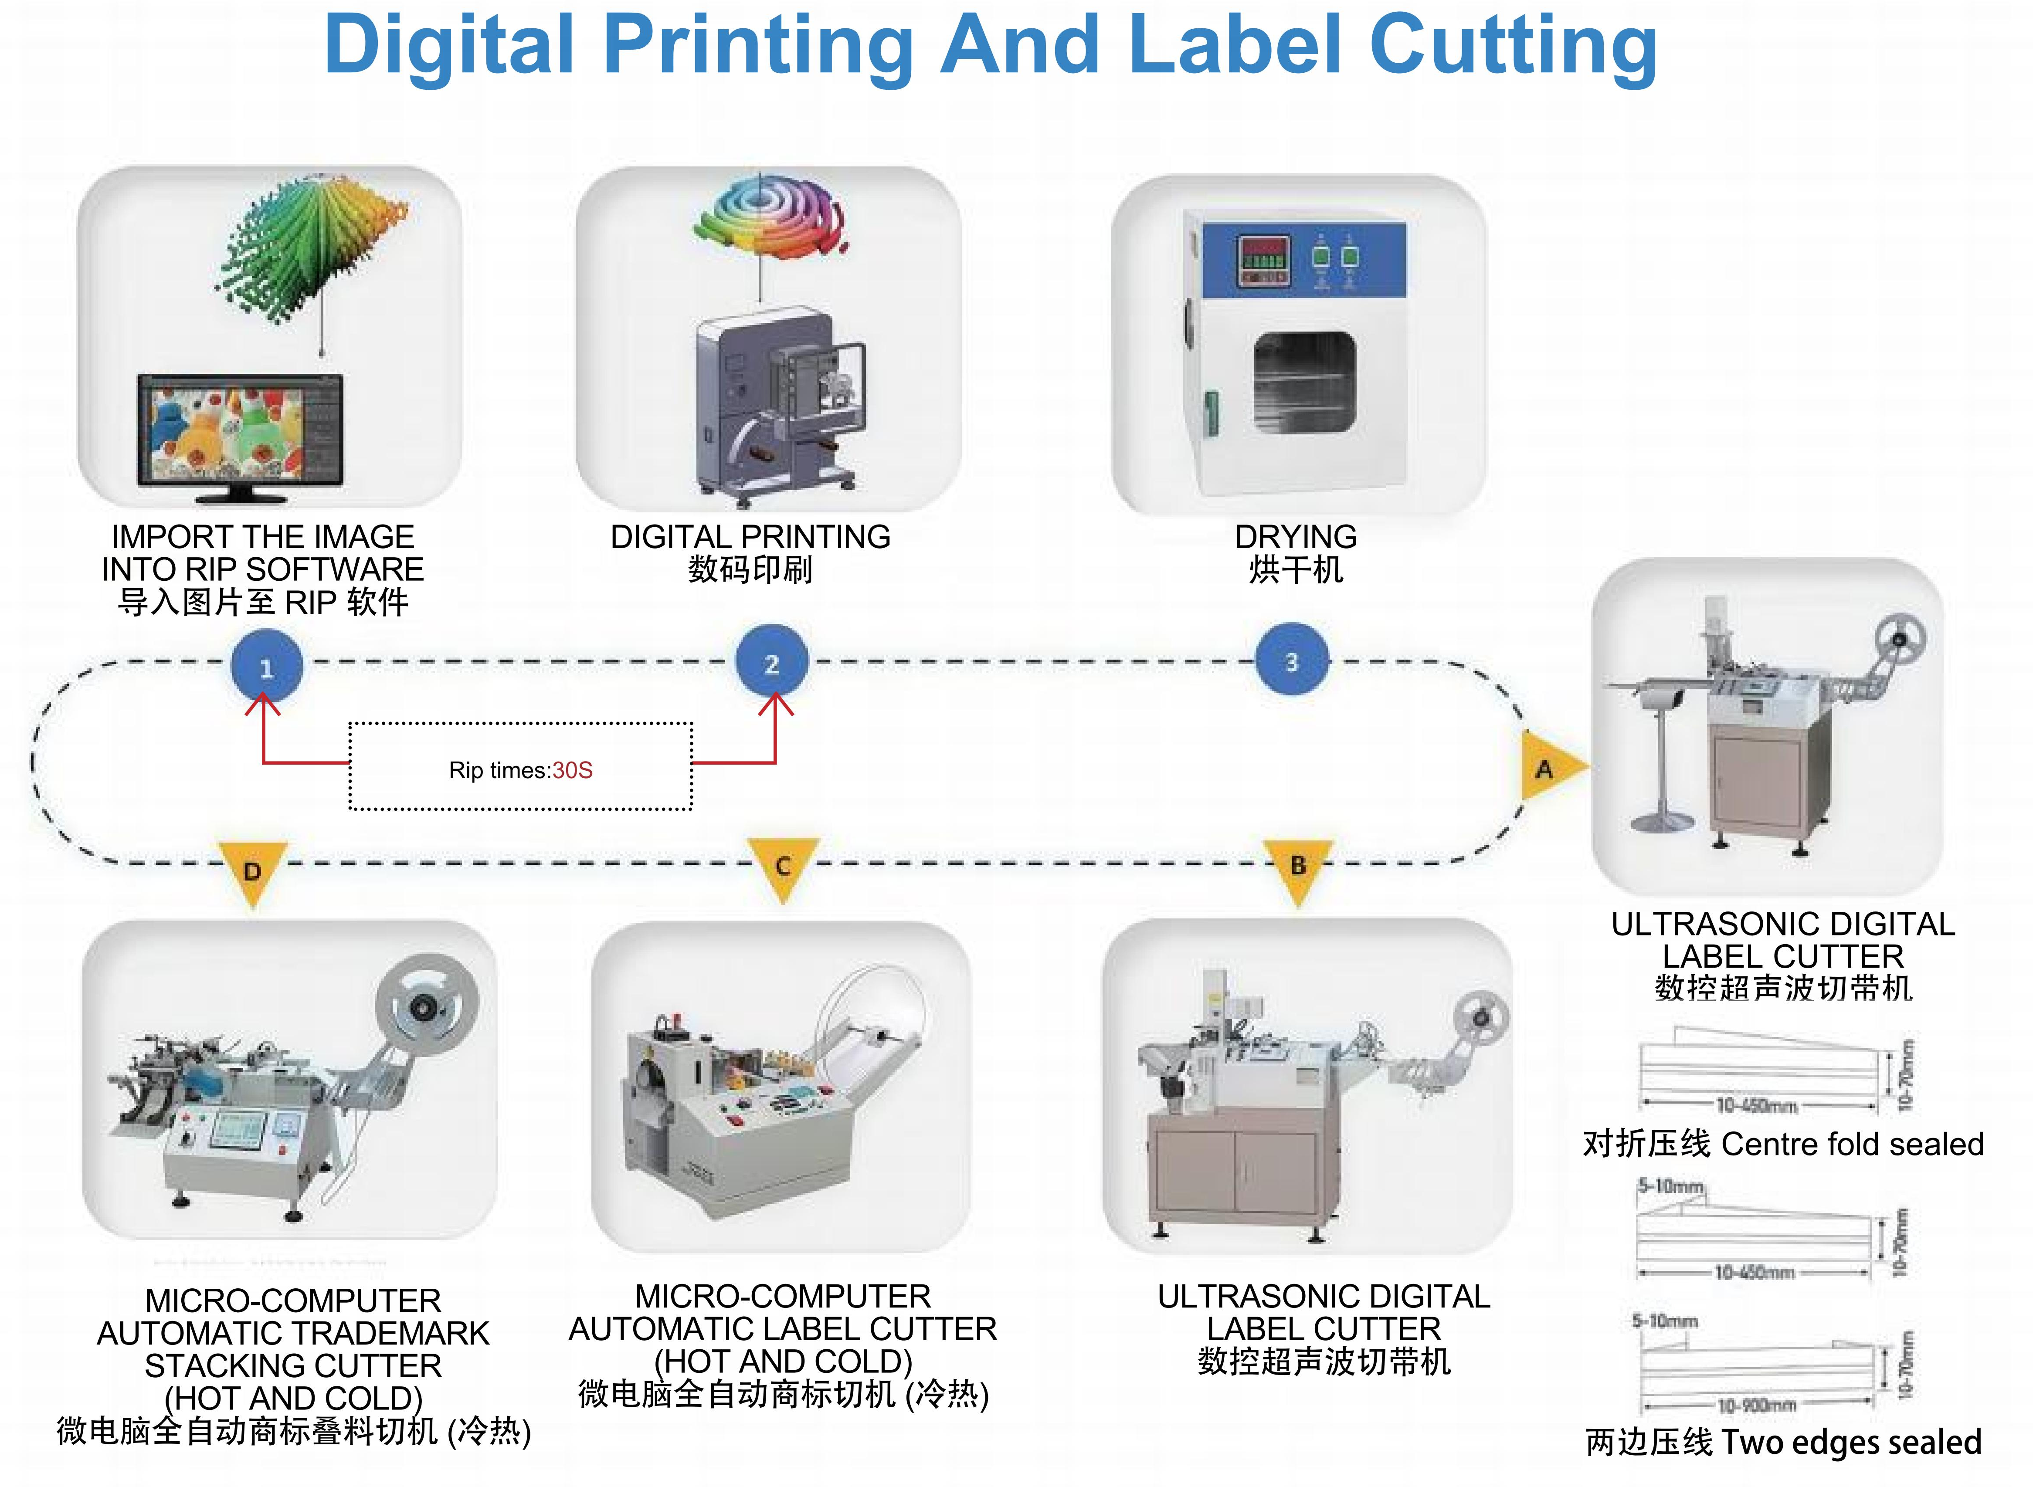
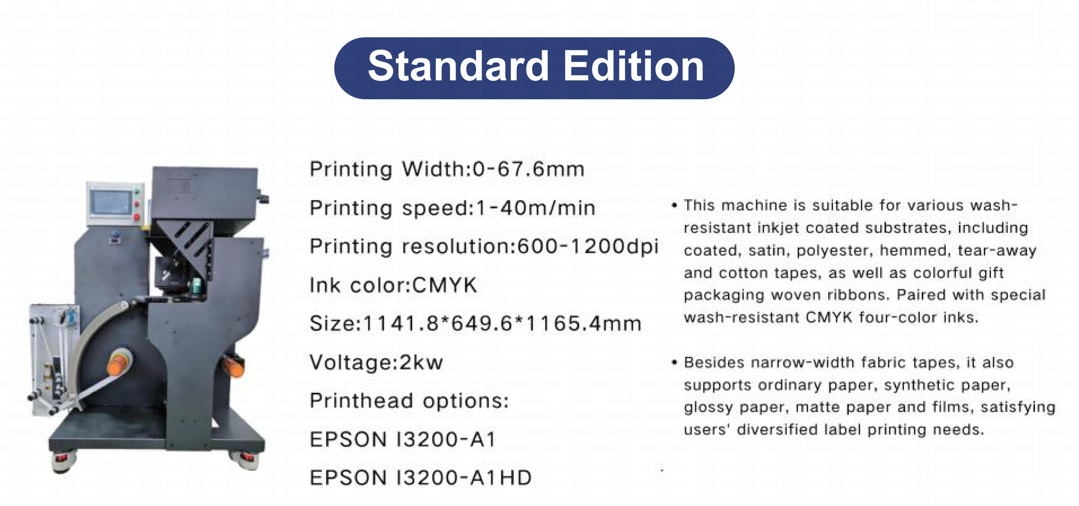
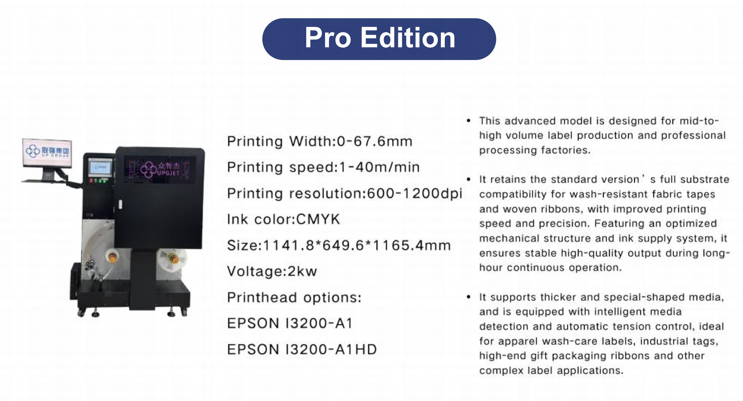
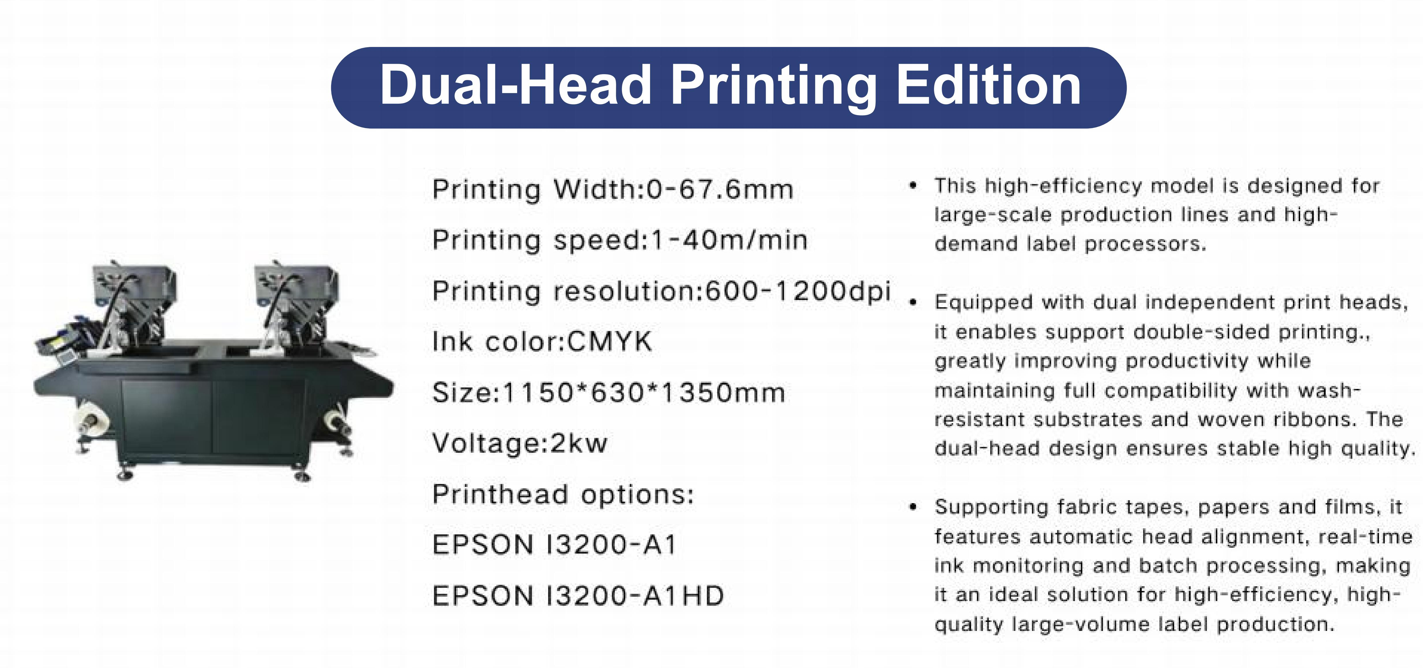
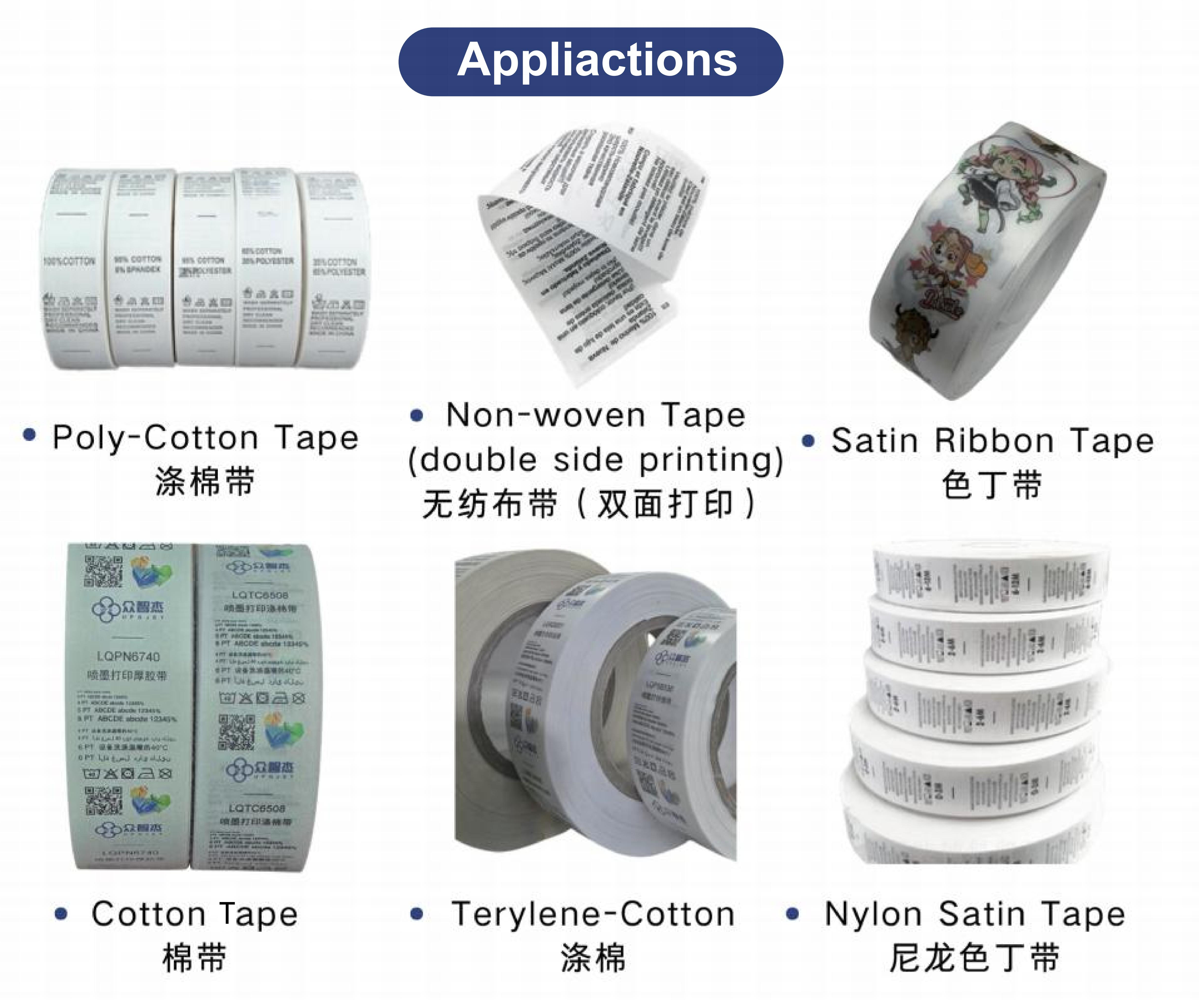

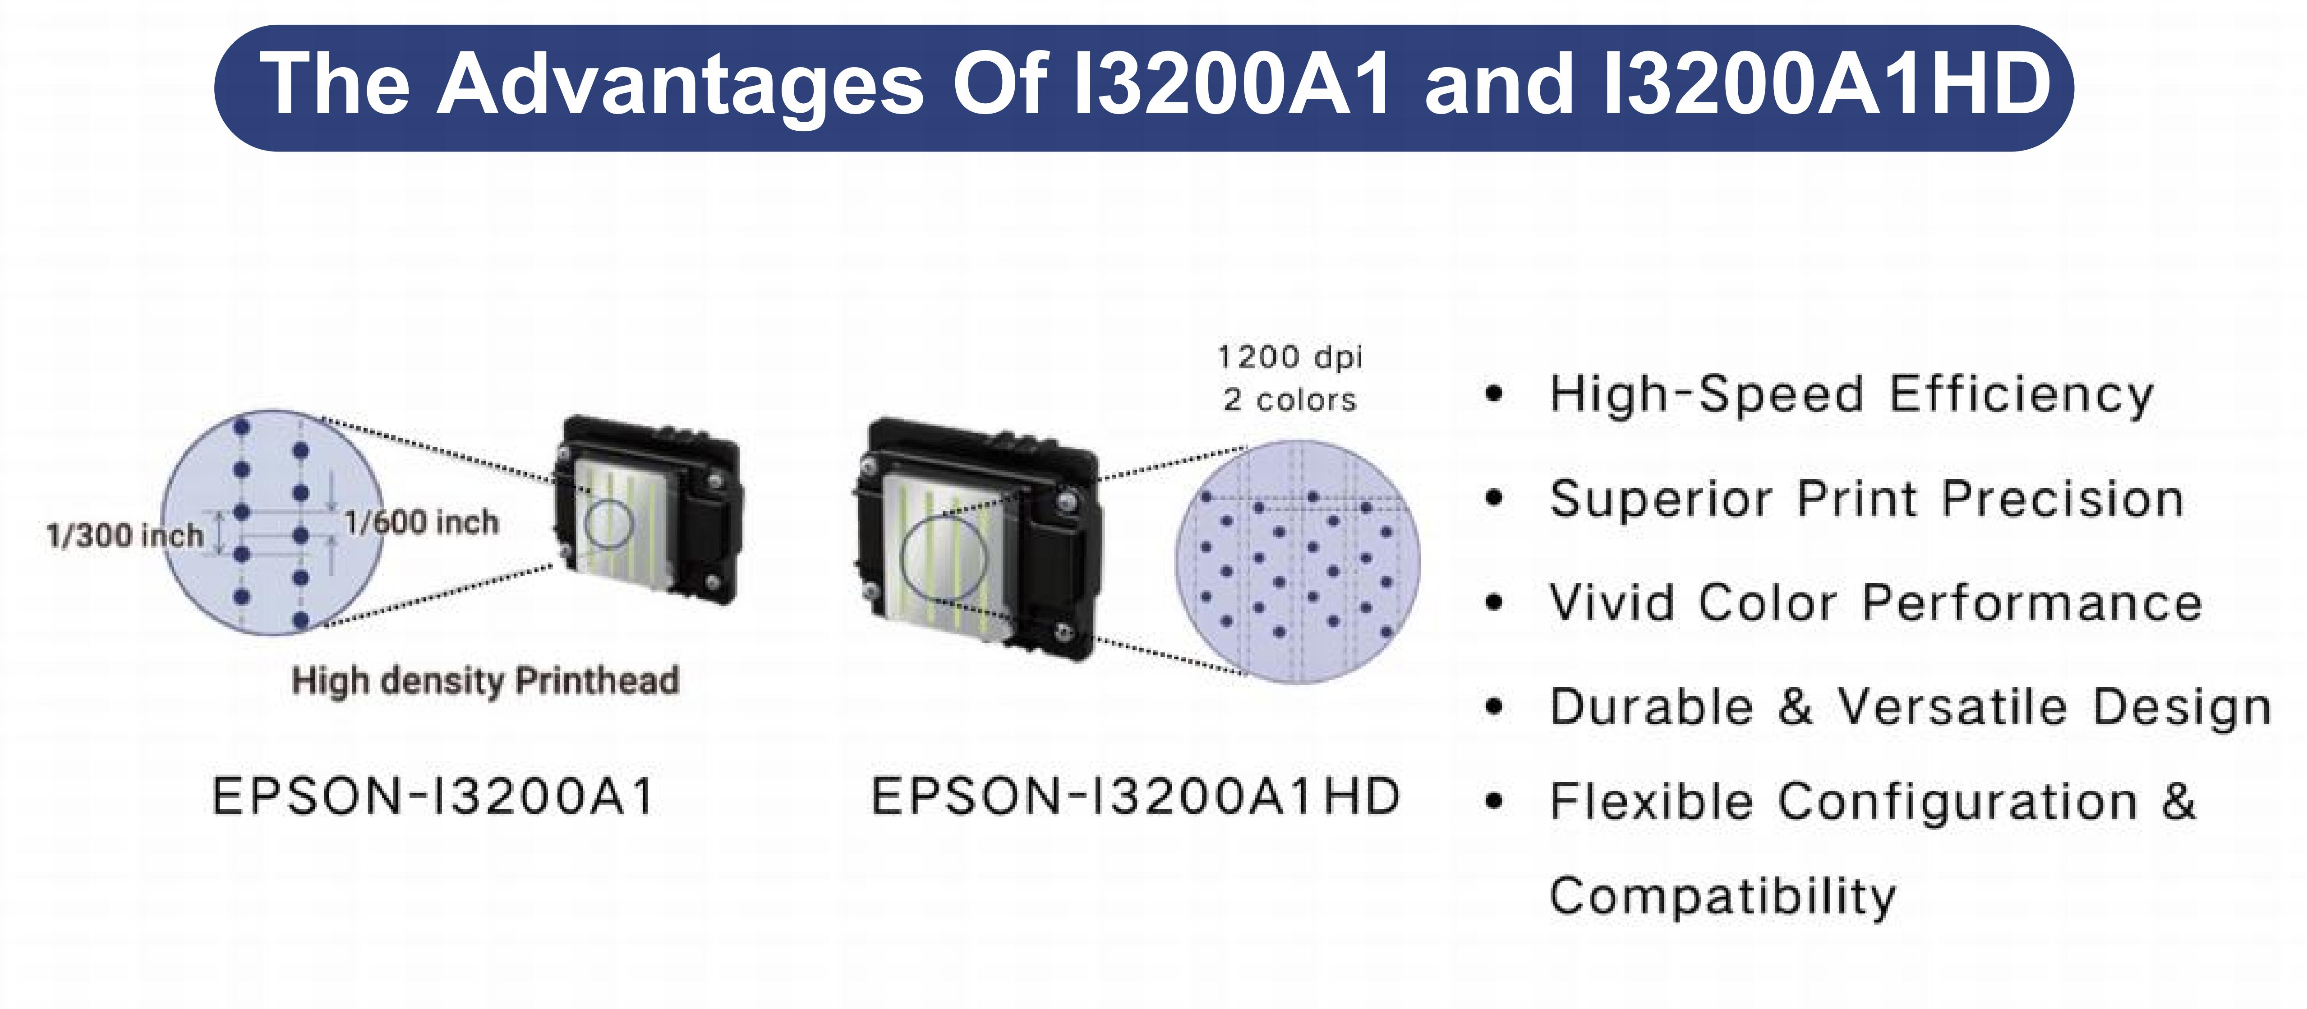

Quotation

MODEL | QUANTITY | PRICE-FOB SHANGHAI
Washing label printer | 1 SET | USD 21000/SET
INK | 1 SET | USD 75/SET
Cleaner | 1 BOTTLE | USD 35/BOTTLE
Printer head | 1 PCS | USD 1200/PCS
- Terms of Payment:
30% deposit by T T when confirming the order
70% balance by T T before shipping.
Or irrevocable L C at sight
- Installation and Training
The price includes the fee of installation, Training and interpreter, However,
the relative cost such as international air tickets between China and
Buyer’s country, local transportation, accommodation (3 star hotel), and the
pocket money USD90 day per person for engineers and interpreter will be
born by buyer. Or, the customer can find capable interpreter in local.
- Validity of Quotation
Until 30th Dec. 2025
- Warranty
12 months after B L date

